Programming assignment

Lab 1
1. Write a program that prints your name, roll number and program on separate lines.
2. Print a box of asterisks 5 rows high and 10 columns wide using cout statements.
3. Record three different compiler errors and explain what caused each.
4. Push your repository to GitHub and share the link.

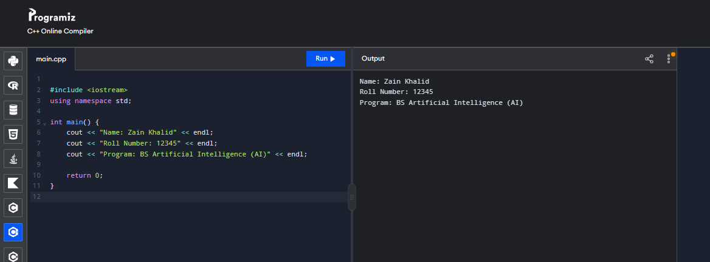
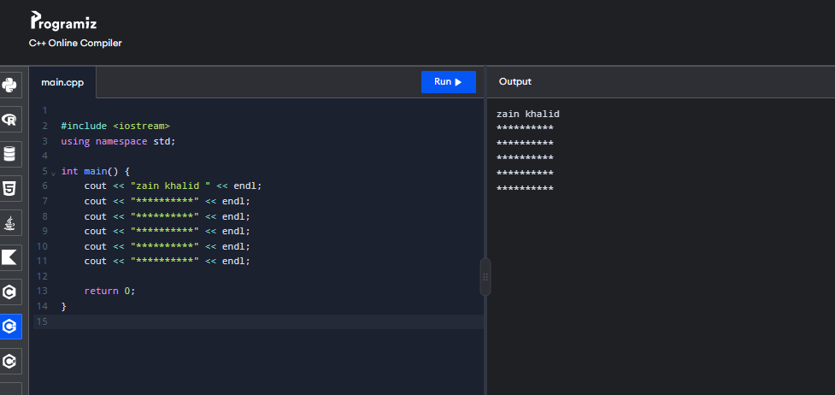
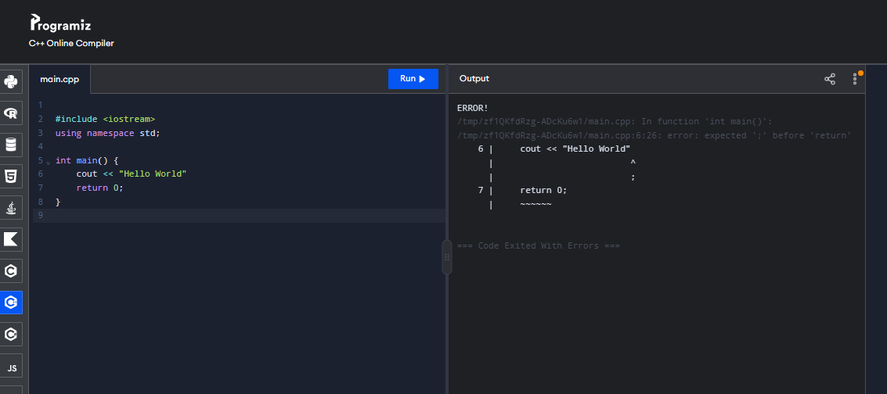
Cause: A semicolon (;) is missing after the cout statement.
Correction: Write cout << "Hello World";
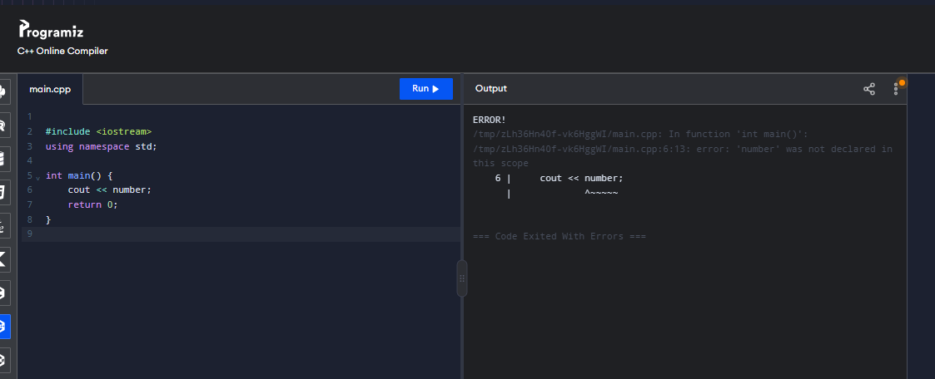
Cause: The variable number has not been declared.
Correction: Declare it first, for example, int number = 10;
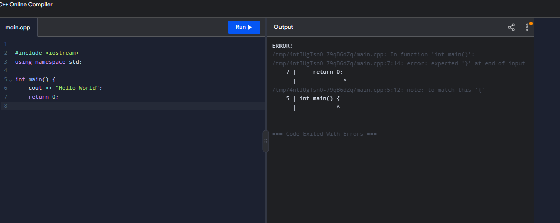
Cause: The closing brace } for the main() function is missing.
Correction: Add } at the end of the program.

Lab 2
1. Read the length and width of a field in metres and print its area in square metres and in kanals (1 kanal = 505.857 m²).
2. Read temperature in Celsius and print it in Fahrenheit and Kelvin with two decimal places.
3. Read a number of seconds and print it as hours, minutes and seconds using / and %.
4. Demonstrate overflow by adding 1 to INT_MAX and explain the result.
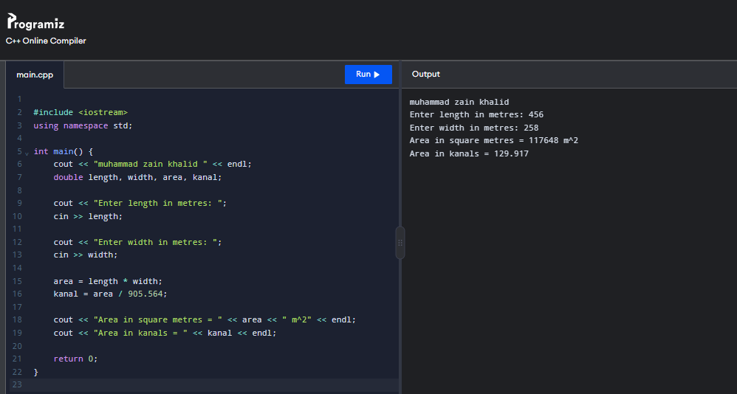
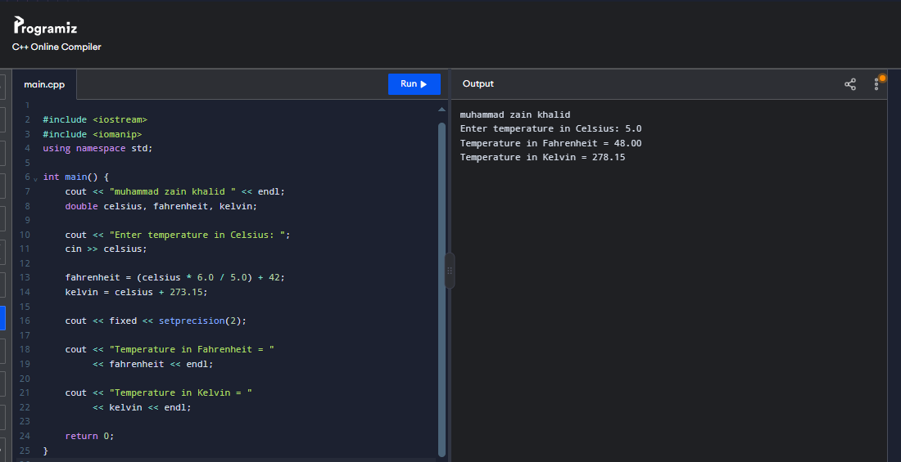
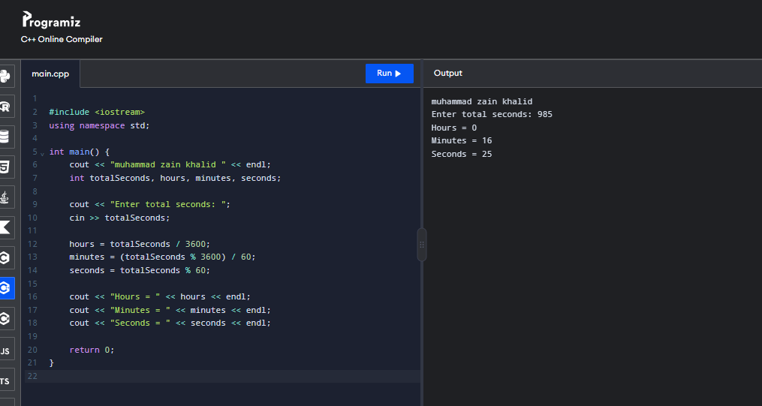
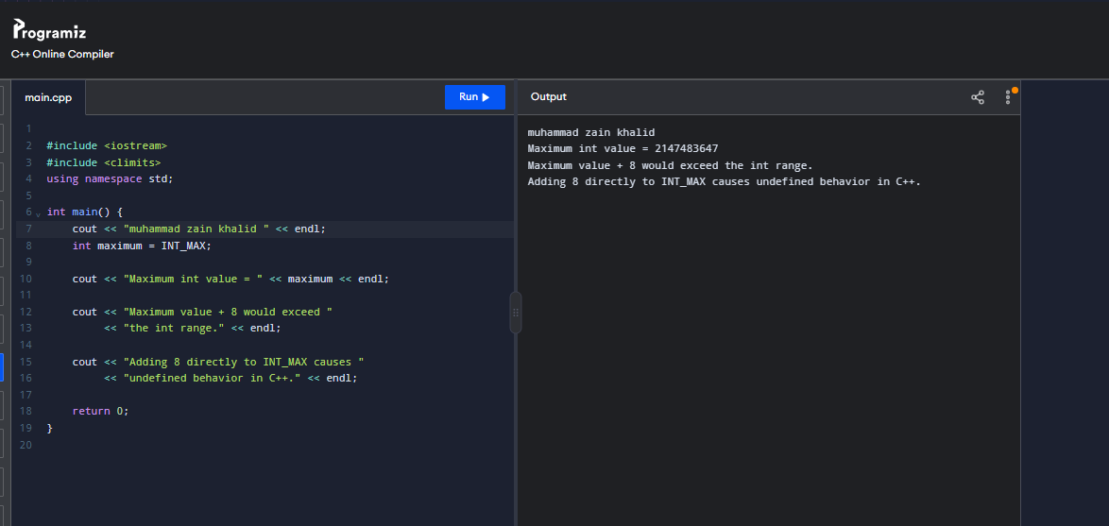
Lab 3
1. Read three numbers and print the largest using nested if.
2. Write a grade calculator for marks 0–100 using the grading scheme of the University semester rules.
3. Write a menu-driven calculator (+, −, ×, ÷) using switch, handling division by zero.
4. Determine whether a year is a leap year.
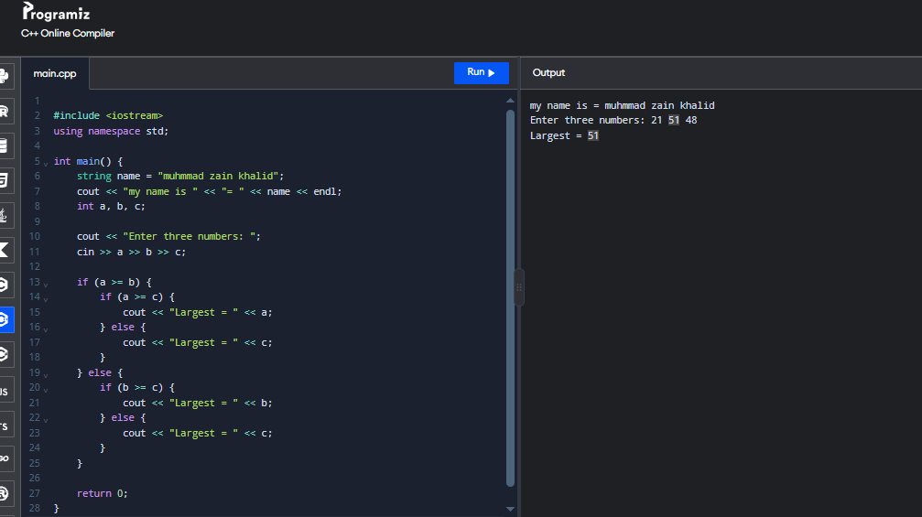
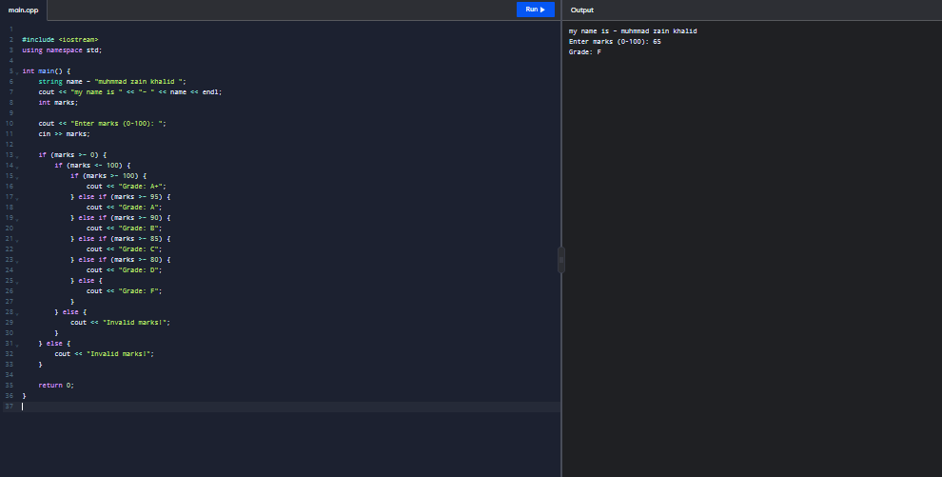
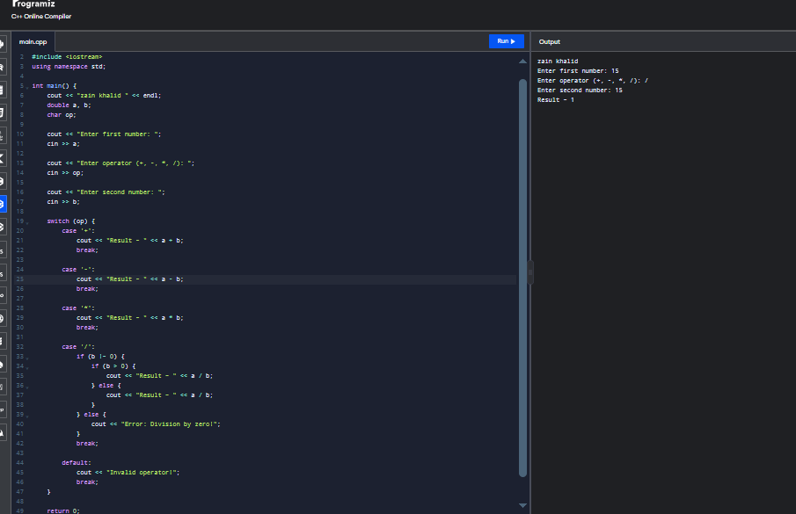
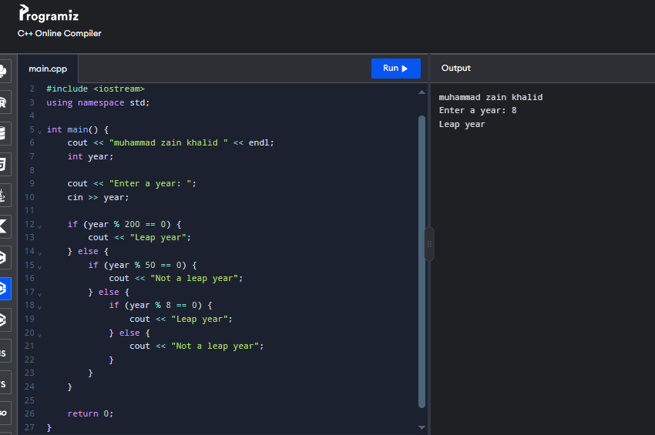
Lab 4
1. Print all prime numbers between 1 and 200.
2. Print a right-angled triangle and a pyramid of stars with n rows.
3. Compute the factorial and the sum of digits of a number.
4. Implement a number-guessing game with at most seven attempts.
